

1. First Palindromic String

CODE:
def firstPalindrome(words):
for word in words:
if word == word[::-1]:
return word
return ""

words = ["abc", "car", "ada", "racecar", "cool"]
print(firstPalindrome(words))

OUTPUT:
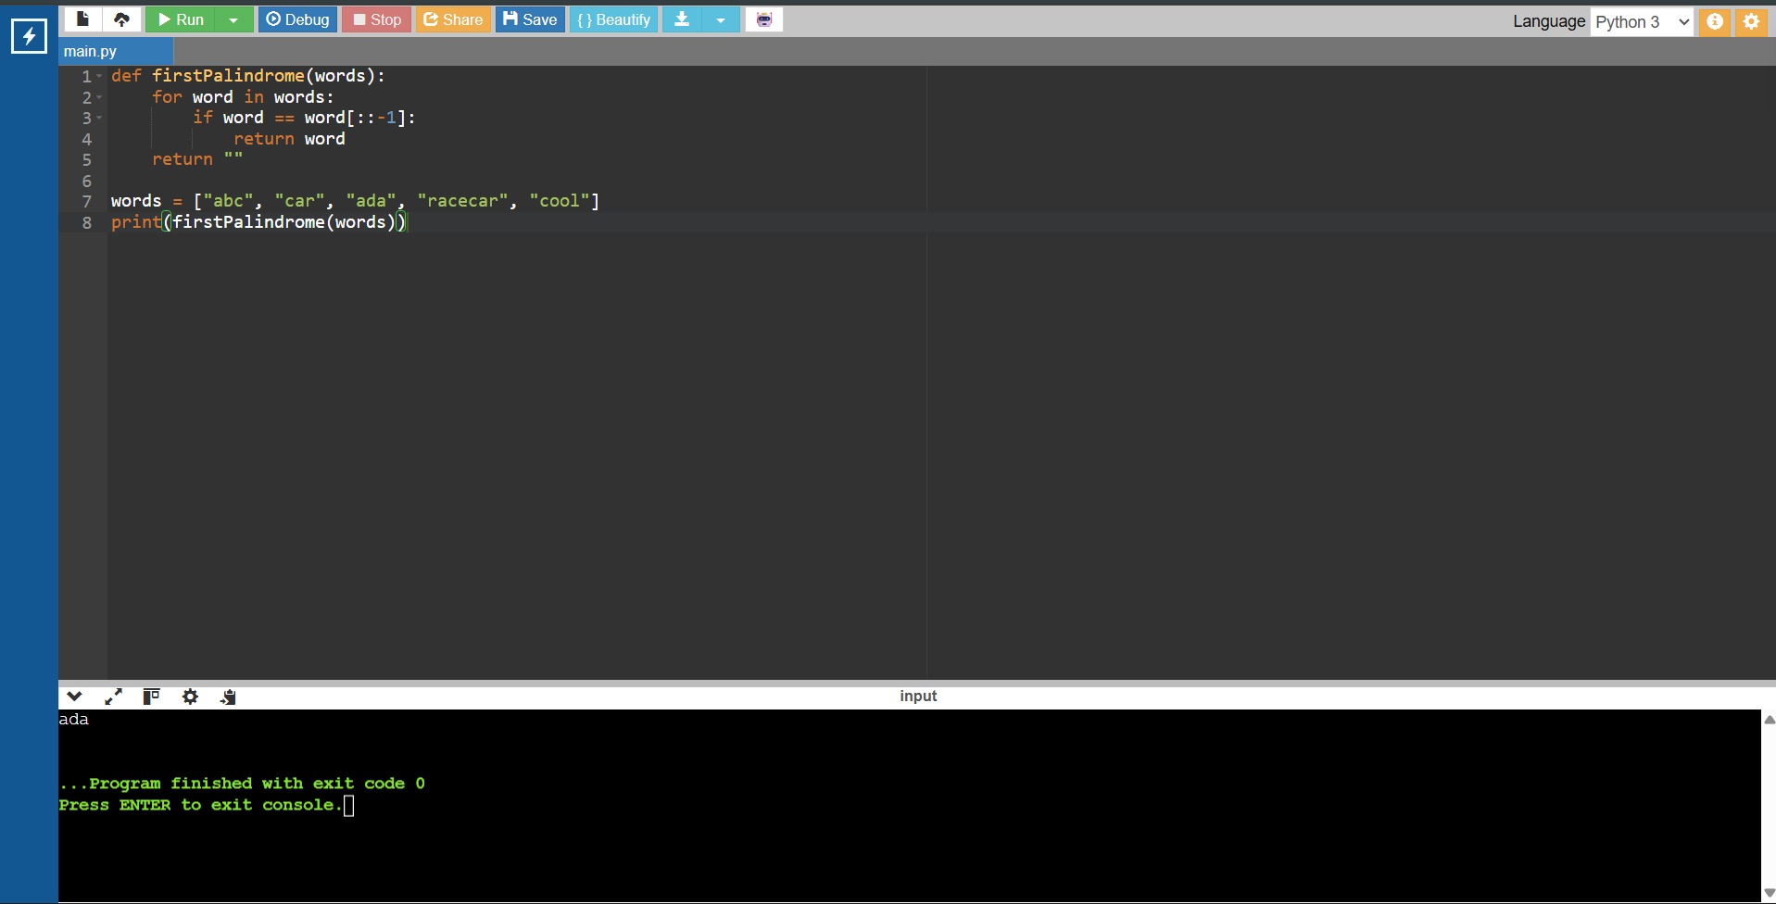

2. Intersection Values

CODE:
def findIntersectionValues(nums1, nums2):
a = sum(x in nums2 for x in nums1)
b = sum(x in nums1 for x in nums2)
return [a, b]

print(findIntersectionValues([2, 3, 2], [1, 2]))

OUTPUT:
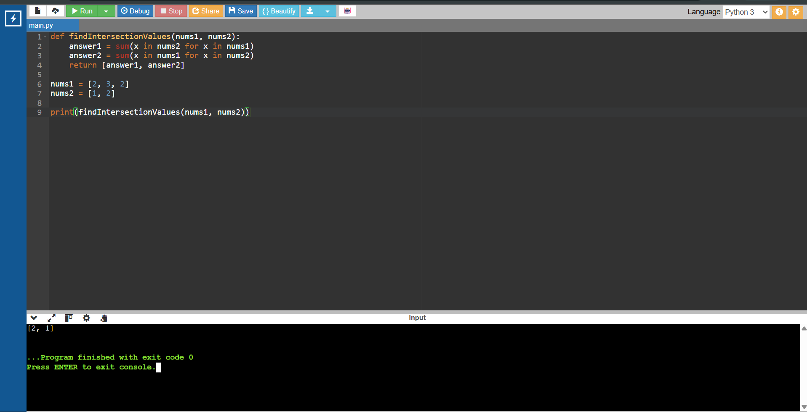

3. Sum of Squares of Distinct Counts

CODE:
def sumCounts(nums):
ans = 0

for i in range(len(nums)):
s = set()
for j in range(i, len(nums)):
s.add(nums[j])
ans += len(s) ** 2

return ans

print(sumCounts([1, 2, 1]))

OUTPUT:
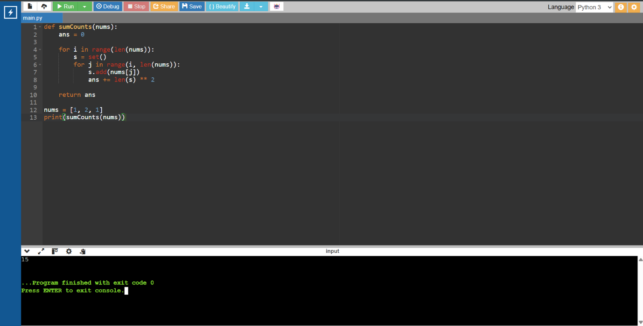

4. Count Valid Pairs

CODE:
def countPairs(nums, k):
count = 0

for i in range(len(nums)):
for j in range(i + 1, len(nums)):
if nums[i] == nums[j] and (i * j) % k == 0:
count += 1

return count

print(countPairs([3, 1, 2, 2, 2, 1, 3], 2))

OUTPUT:
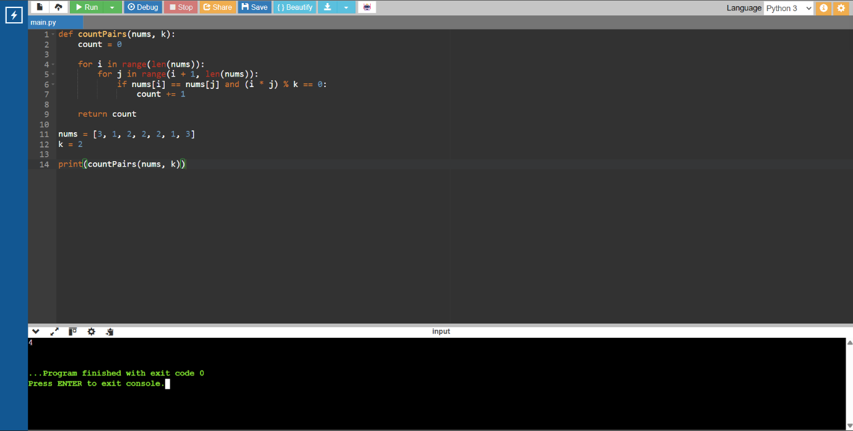

5. Find Maximum Element

CODE:
def findMax(nums):
maximum = nums[0]

for x in nums:
if x > maximum:
maximum = x

return maximum

print(findMax([1, 2, 3, 4, 5]))
print(findMax([7, 7, 7, 7, 7]))
print(findMax([-10, 2, 3, -4, 5]))

OUTPUT:
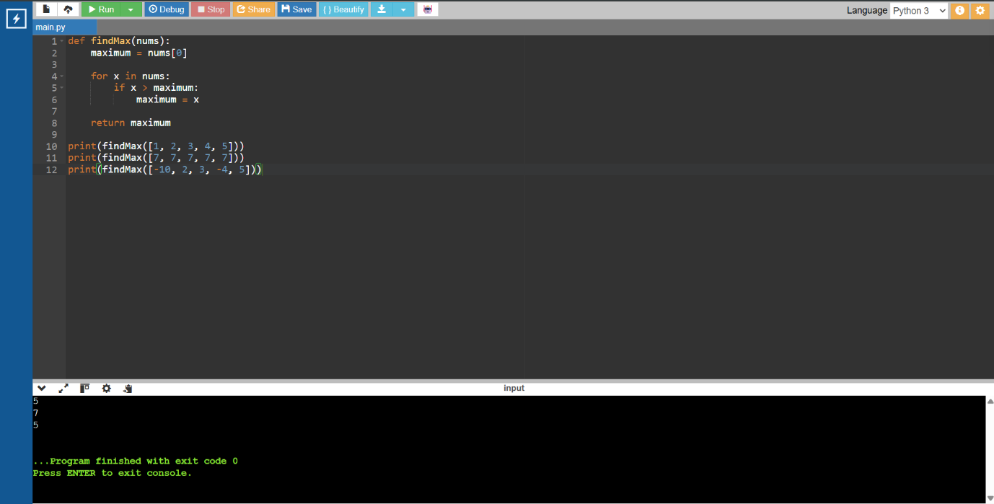

6. Find Max

CODE:
def findMax(nums):
if not nums:
return None

nums.sort()
return nums[-1]

print(findMax([]))
print(findMax([5]))
print(findMax([3, 3, 3, 3, 3]))

OUTPUT:
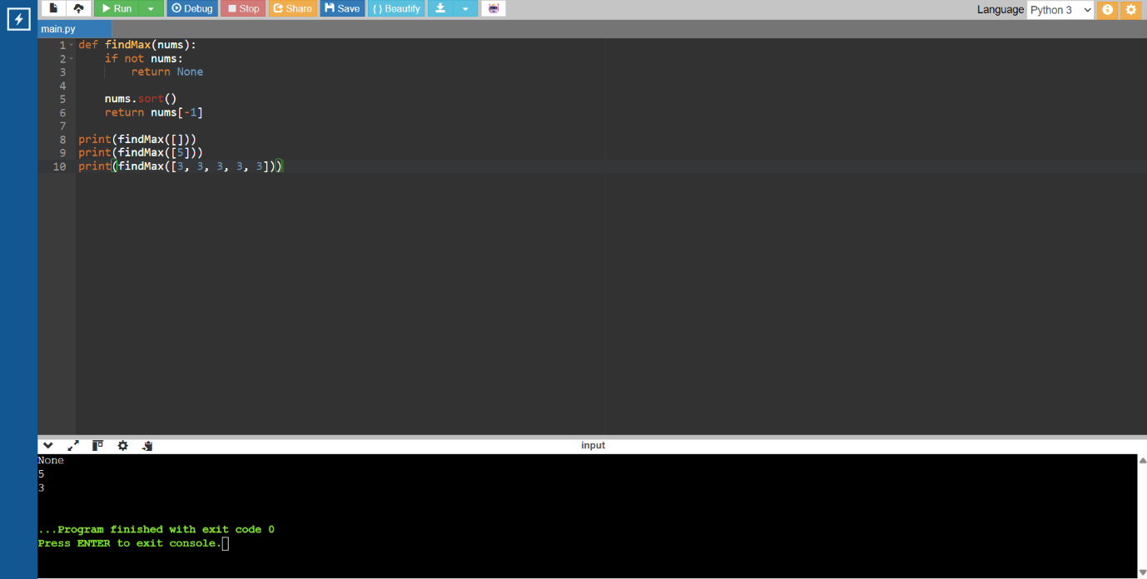

7. Remove Duplicate Elements

CODE:
def unique(nums):
result = []

for x in nums:
if x not in result:
result.append(x)

return result

print(unique([3, 7, 3, 5, 2, 5, 9, 2]))
print(unique([-1, 2, -1, 3, 2, -2]))
print(unique([1000000, 999999, 1000000]))

OUTPUT:
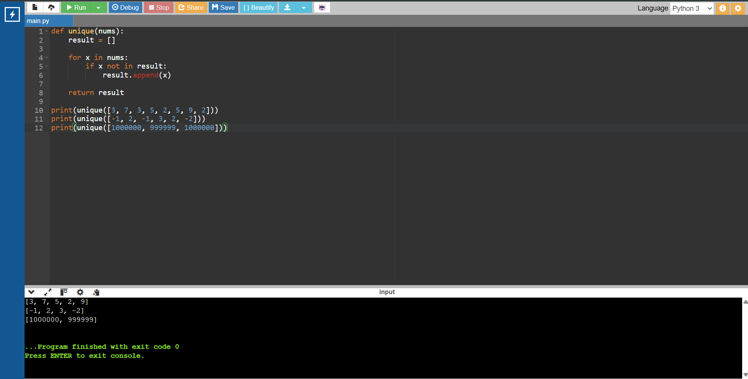

8. Bubble Sort

CODE:
def bubbleSort(arr):
n = len(arr)

for i in range(n):
for j in range(0, n-i-1):
if arr[j] > arr[j+1]:
arr[j], arr[j+1] = arr[j+1], arr[j]

return arr

print(bubbleSort([5, 2, 8, 1, 3]))

OUTPUT:
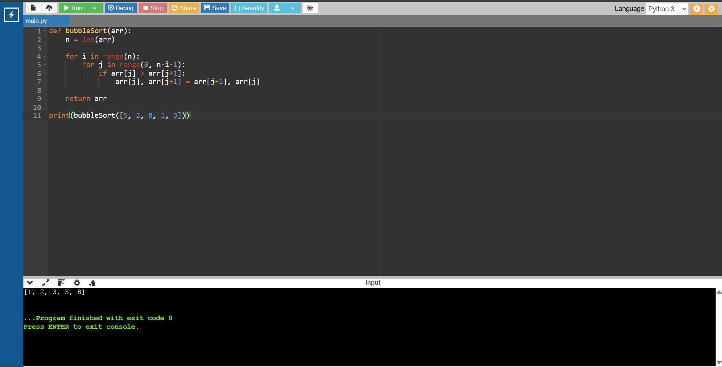

9. Binary Search
CODE:
def binarySearch(arr, key):
low = 0
high = len(arr) - 1
while low <= high:
mid = (low + high) // 2
if arr[mid] == key:
return mid
elif arr[mid] < key:
low = mid + 1
else:
high = mid - 1
return -1
arr = [-9, 3, 4, 6, 8, 9, 10, 30]
key = 10
pos = binarySearch(arr, key)
if pos != -1:
print("Element", key, "is found at position", pos + 1)
else:
print("Element", key, "is not found")

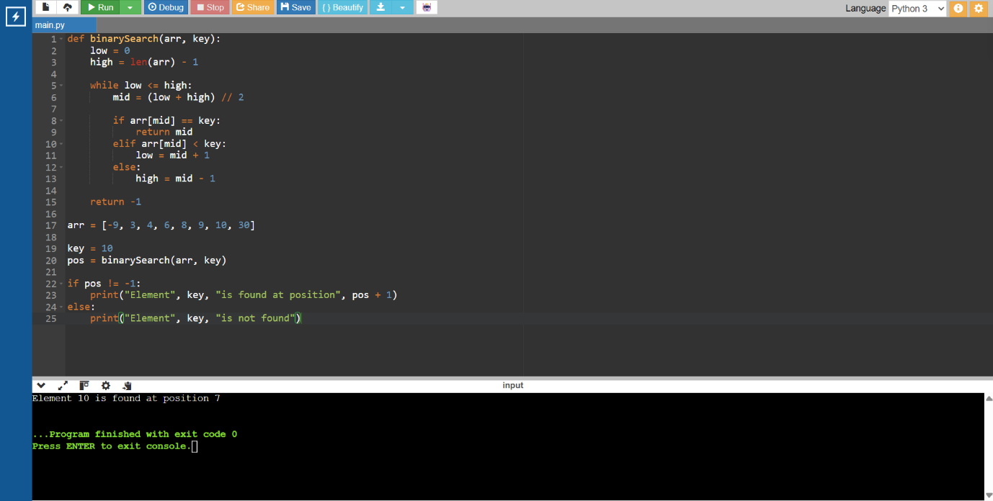
OUTPUT:

10. Sort Array in O(n log n)
CODE:
def mergeSort(arr):
if len(arr) <= 1:
return arr
mid = len(arr) // 2
left = mergeSort(arr[:mid])
right = mergeSort(arr[mid:])
result = []
i = j = 0
while i < len(left) and j < len(right):
if left[i] < right[j]:
result.append(left[i])
i += 1
else:
result.append(right[j])
j += 1
result += left[i:]
result += right[j:]
return result
print(mergeSort([5, 2, 8, 1, 3]))

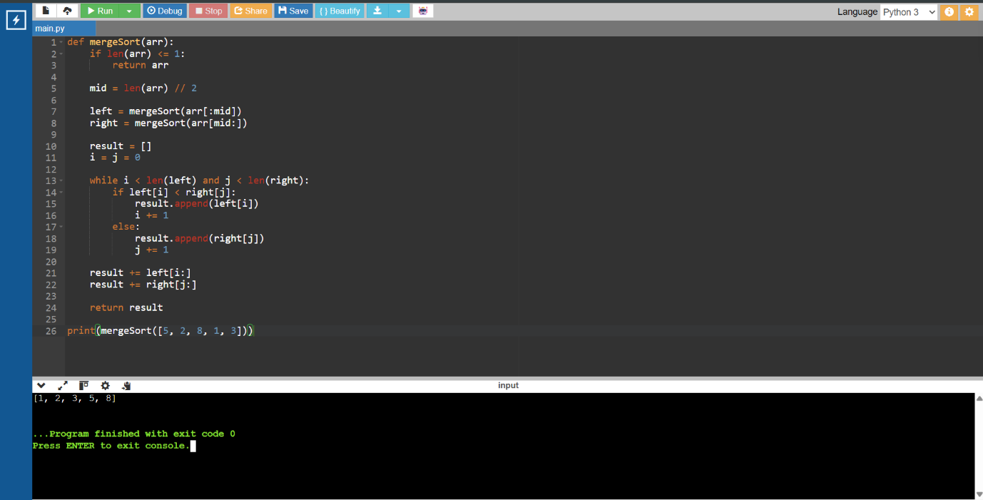
OUTPUT:

11. Ball Out of Grid
CODE:
def findPaths(m, n, N, i, j):
dp = [[0] * n for _ in range(m)]
dp[i][j] = 1
ans = 0
for _ in range(N):
new = [[0] * n for _ in range(m)]
for r in range(m):
for c in range(n):
if dp[r][c]:
for dr, dc in [(1,0), (-1,0), (0,1), (0,-1)]:
nr, nc = r + dr, c + dc
if nr < 0 or nr >= m or nc < 0 or nc >= n:
ans += dp[r][c]
else:
new[nr][nc] += dp[r][c]
dp = new
return ans
print(findPaths(2, 2, 2, 0, 0))
print(findPaths(1, 3, 3, 0, 1))
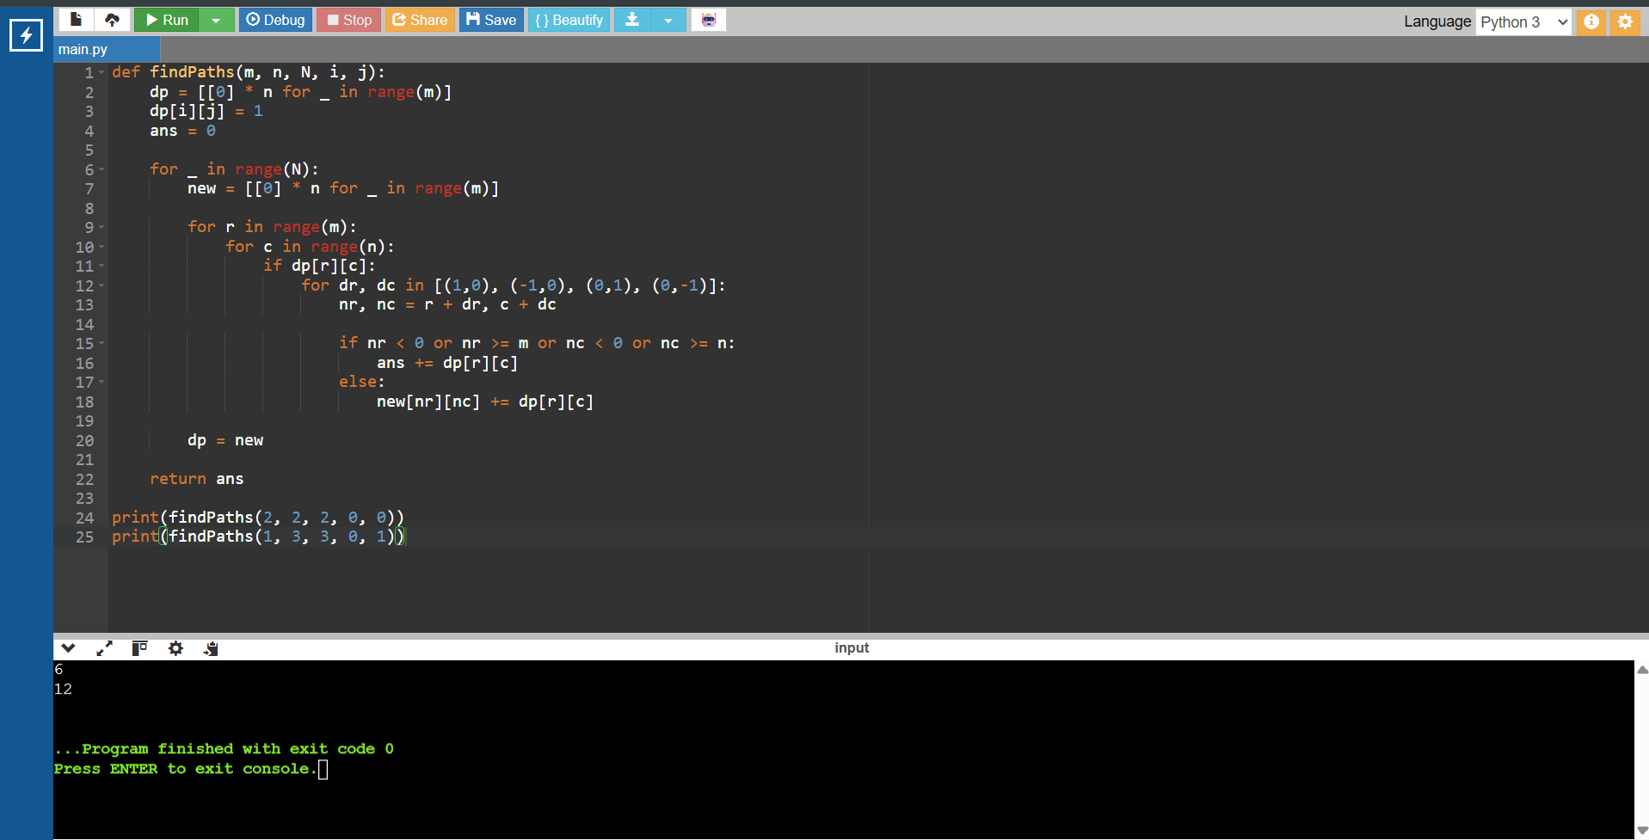
OUTPUT:

12. House Robber II
CODE:
def rob(nums):
if len(nums) == 1:
return nums[0]
def helper(arr):
prev = curr = 0
for x in arr:
prev, curr = curr, max(curr, prev + x)
return curr
return max(helper(nums[:-1]), helper(nums[1:]))
print(rob([2, 3, 2]))
print(rob([1, 2, 3, 1]))

OUTPUT:
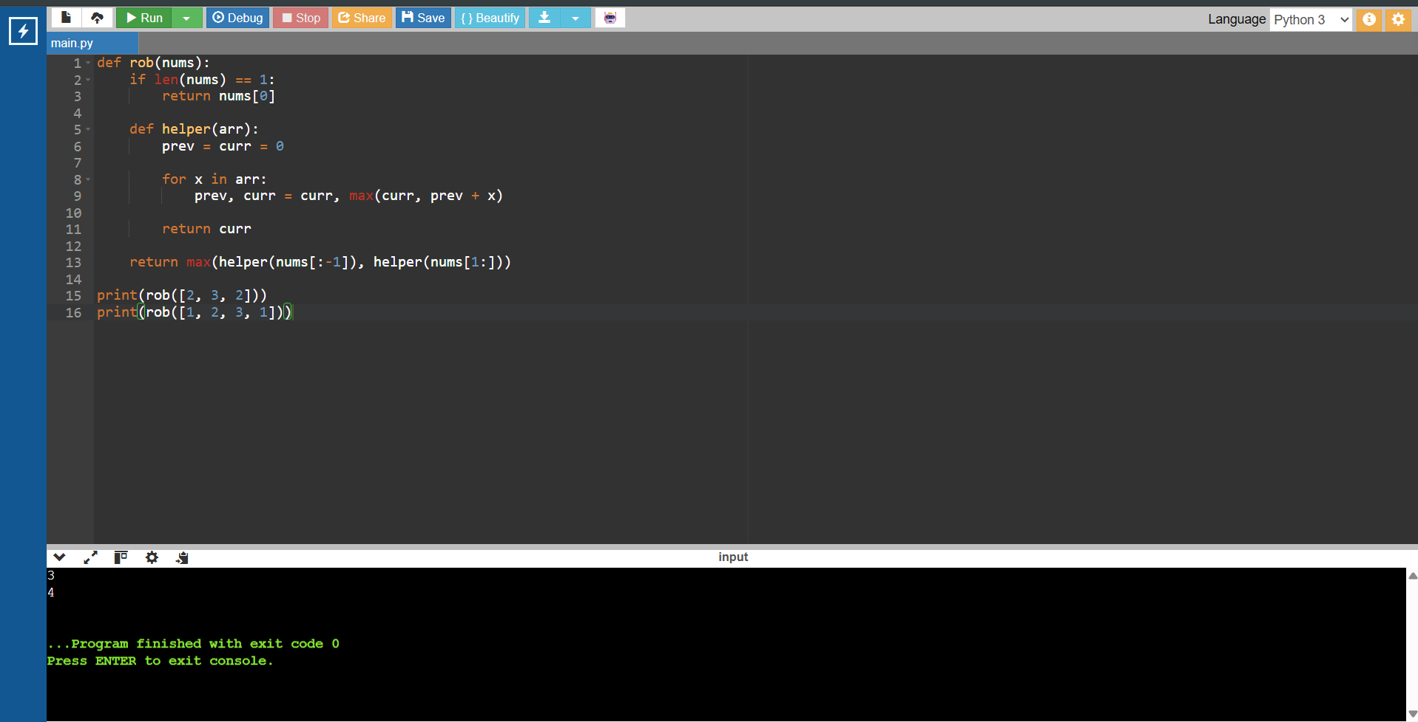

13. Climbing Stairs

CODE:
def climbStairs(n):
a, b = 1, 1

for _ in range(n):
a, b = b, a + b

return a

print(climbStairs(4))
print(climbStairs(3))

OUTPUT:
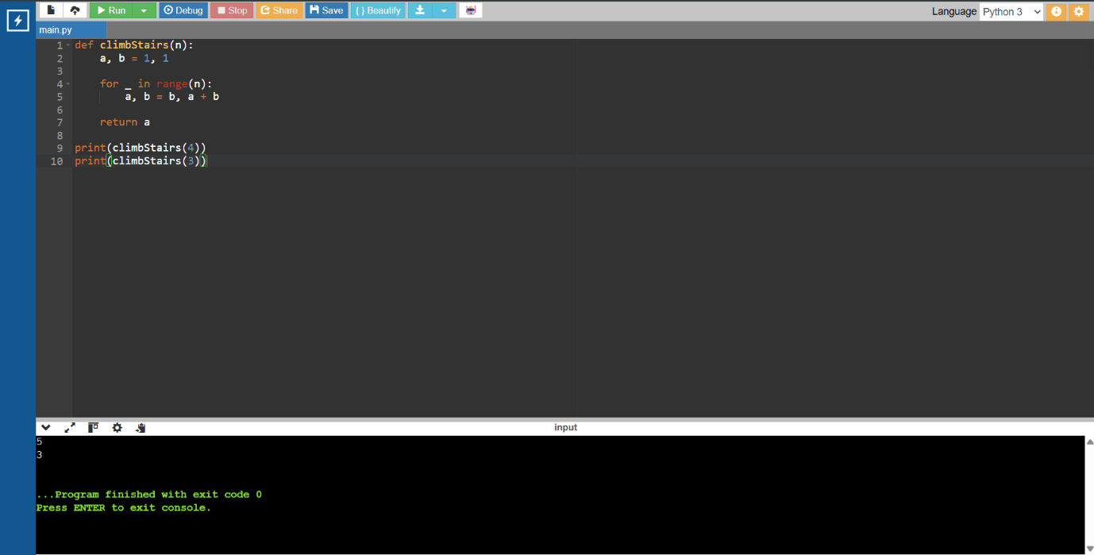

14. Unique Paths

CODE:
def uniquePaths(m, n):
dp = [1] * n

for i in range(1, m):
for j in range(1, n):
dp[j] += dp[j - 1]

return dp[-1]

print(uniquePaths(7, 3))
print(uniquePaths(3, 2))

OUTPUT:
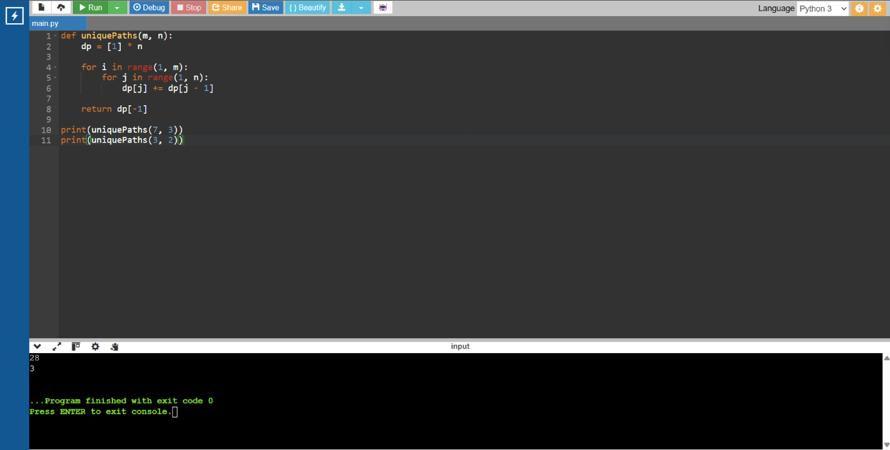

15. Large Groups in String

CODE:
def largeGroups(s):
result = []
start = 0
for i in range(1, len(s) + 1):
if i == len(s) or s[i] != s[i - 1]:
if i - start >= 3:
result.append([start, i - 1])
start = i
return result
print(largeGroups("abbxxxxzzy"))
print(largeGroups("abc"))

OUTPUT:
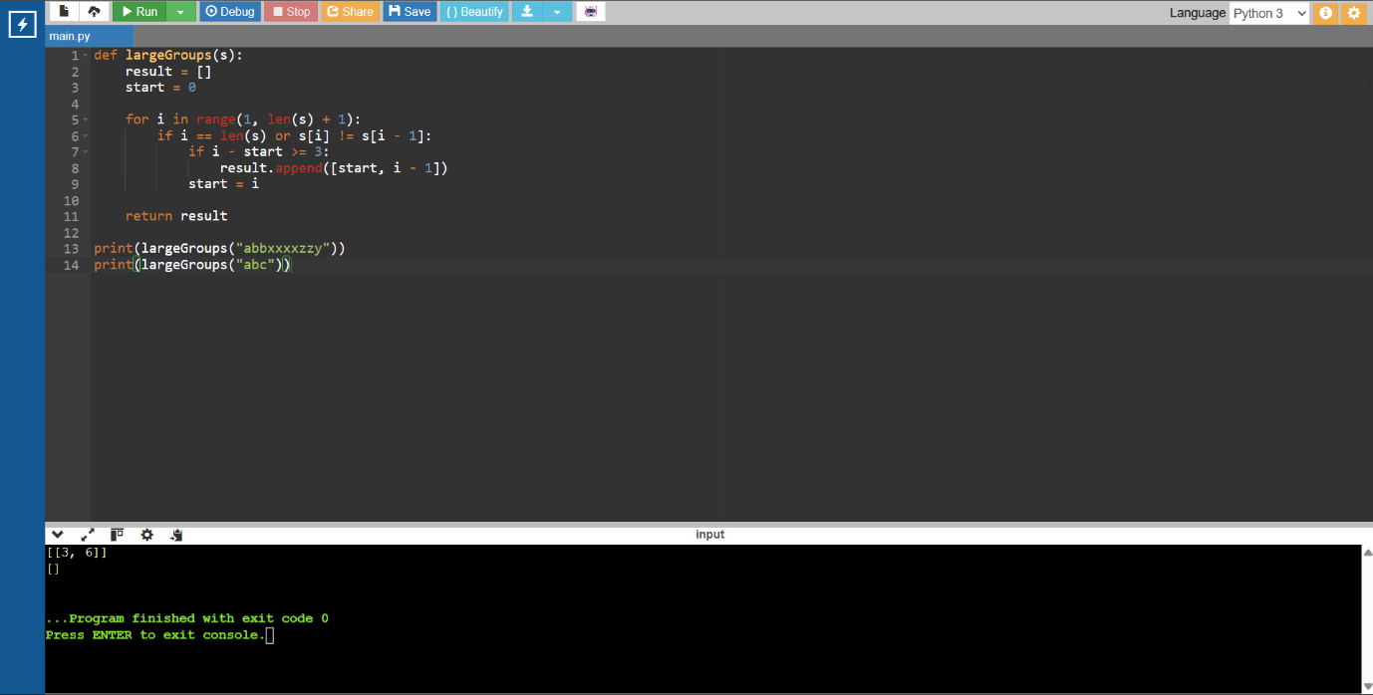

16. Champagne Tower

CODE:
def champagneTower(poured, query_row, query_glass):
glasses = [[0] * 101 for _ in range(101)]
glasses[0][0] = poured
for i in range(100):
for j in range(i + 1):
if glasses[i][j] > 1:
extra = (glasses[i][j] - 1) / 2
glasses[i + 1][j] += extra
glasses[i + 1][j + 1] += extra
return min(1, glasses[query_row][query_glass])
print(champagneTower(1, 1, 1))
print(champagneTower(2, 1, 1))

OUTPUT:
